Feature: Preview Track

**January 19th 2023**

# **OBJECTIVE**

To allow users to preview songs from the search results and playlist.

**BACKGROUND**

At the moment the Web App is able to search on spotify tracks and add them to a new playlist, but in case the user is not sure about adding a particular is not able to listen a sample of the track to decide wether to add it or not.

This feature accomplises:

* Allow user to listen a 30s sample of the desired song.
* The user will have controls to play/pause the track sample as well as   
  control the volume.
* If a track its playing at the time the user selects a different song sample, the   
  previous son will be paused.
* This feature will be incorporated also to playlist’s tracks.

# **TECHNICAL DESIGN**

Retrieve and Display song preview.

The level of complexity to incorporate this feature it’s not high. First we update the **search( )** method inside the Spotify object on **Spotify.js** we are going to add the preview_url attribute to our tracks to extract the url where our sample its located.

In **Track.js** render function we add a <audio> element under the paragraph displaing artist and album information, setting audio source to **src={this.props.track.preview}.**

Because we are adding the audio element into the **Track Component** the user will be able to preview the song from songs added to **Playlist.**

Once implemented the component should like like bellow:

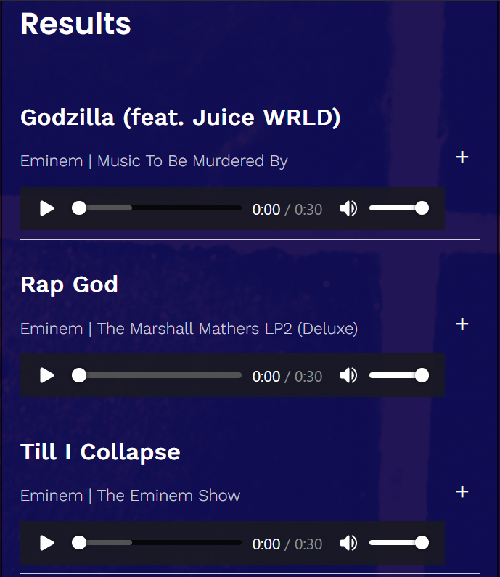

# **CAVEATS**

Due to the simplicity of the task, wich add an extra parameter per track i couldnt find any more suitable execution as the one described on the tecnical design section, its quick reliable and in my opinion the perfect fit for the feature.